**Grove - I2C Hub**

窗体顶端

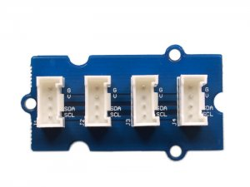

http://www.seeedstudio.com/depot/includes/templates/pure_green/images/next_l.gif

* [http://www.seeedstudio.com/depot/bmz_cache/4/419f3d1e4671e48f4d5260664d26126e.image.55x41.jpg](http://www.seeedstudio.com/depot/images/product/12C%20hub.jpg)
* [http://www.seeedstudio.com/depot/bmz_cache/a/aa01740cc7b47848e13ae325dc1d531b.image.55x41.jpg](http://www.seeedstudio.com/depot/images/product/12C%20hub_01.jpg)
* [http://www.seeedstudio.com/depot/bmz_cache/b/b08089b43014863103f047ca3ec90b7f.image.55x41.jpg](http://www.seeedstudio.com/depot/images/product/12C%20hub_02.jpg)

http://www.seeedstudio.com/depot/includes/templates/pure_green/images/next_r.gif

* **Price:**

$2.90  [(Price Feedback)](javascript:void())

* **SKU:**

ACC53133P

* **Weight:**

5Gram

* **Units in Stock**

59

* **Designed by:**

[Seeed Studio](http://www.seeedstudio.com/)



[Other products from designer](http://www.seeedstudio.com/depot/seeed-studio-m-23.html)

* **Quantity:** Max: 59  
  
* [Add to Wish List](http://www.seeedstudio.com/depot/index.php?main_page=un_wishlist&products_id=851&cPath=178_191&action=un_add_wishlist)

Description

I2C Hub Grove is an extension Grove module for connecting multiply I2C devices to Grove Base Shield. It can use with [Universal 4 Pin to X2 4 Pin cable](http://www.seeedstudio.com/depot/universal-4-pin-to-x2-4-pin-cable-5-pcs-pack-p-847.html?cPath=178_179) and connects up to 7 I2C divices which may cover most developing purpose.

**Documents**

Please visit our[wiki page](http://garden.seeedstudio.com/index.php?title=Twig_-_I2C_Hub)for more info about this product. It will be appreciated if  you can help us improve the documents, add more demo code or tutorials. For technical support, please post your questions to our [forum](http://www.seeedstudio.com/forum).

窗体底端